**Overview of Project**

Our proposal for Pitt Bop It is “Dispose It”. It will be a Bop It that incorporates several waste disposal methods and will be used as a way to teach children/users in what ways certain types of waste should be disposed of. The three actions on Dispose It will be Trash It, Recycle It, and Compost it. Our proposal will have “Trash It” be a push button that has a trash can as the button’s design. “Recycle It” will involve a twisting mechanism that has the design of a recycling symbol. “Compost It” will be a pulling motion with a leaf as its design.

“Dispose It” will be designed as a 3D cube with three buttons attached to its sides and used for the directed actions. The front face of the cube will contain the speaker for audio cues and a screen (either LCD or Hex) that will let the user know what their current score is.The mechanism will be a way to teach users about waste disposal methods so the toy will prompt users by saying a piece of waste, and the user selects the correct disposal method. For example, when the device says paper, the user would twist Recycle It. When the device says plastic bag, the user would push Trash It. When the device says banana peel, the user would pull Compost It.

**Block Diagram**

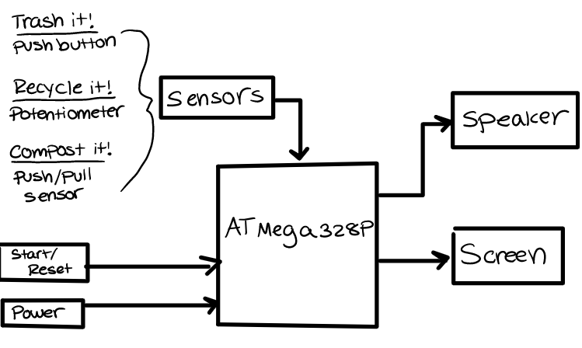

**Pseudo Code**

main(){

score()

currentCommand()

checkUserInput()

trashIt()

recycleIt()

compostIt()

endGame()

timer()

screenDisplay()

audio()

}

score

* tracks the score
* ends game when score hits 99

currentCommand

* randomly selects a command and calls audio function to output audio on speaker

checkUserInput

* receives expected input from currentCommand and waits for user checkUserInput
* checks if command is correct
* if interrupted by timer expiration before user input, endGame

trashIt

* interfaces with trashIt push button and detects user input on button

recycleIt

* interfaces with recycle It push button and detects user input on twisting mechanism

compostIt

* interfaces with compostIt push button and detects user input on pull mechanism

endGame

* gives user on score on screen, and gives user score via audio

timer

* keeps track of time interval
* speeds up time interval as game goes on

screenDisplay

* displays score to user via display screen

audio

* controls output to speaker

**Sketch of Enclosure**

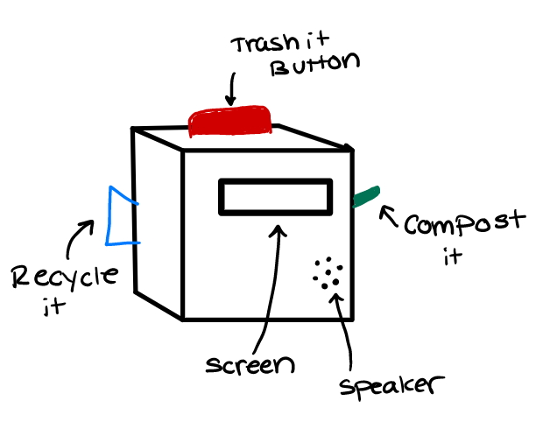

**Team Roles**

**Hardware:** Rayan Hassan

**Software:** Destiny Elings

**Enclosure:** Ashley Ajuz

**BOM Items**

* Buttons [ Trash It, Reset]
* <https://www.digikey.com/en/products/detail/e-switch/RA11131121/2720267> Rocker Switch [ Power]
* LCD Display
* Speaker
* Flex Sensor
* Potentiometer /Rotary Encoder with clicks [ Recycle it]
* Lever
* Conductive tape for pulling sensor ( when a lever is pulled, two sides of tape touch to complete the connection)
* <https://wiki.dfrobot.com/DFPlayer_Mini_SKU_DFR0299>

**New BOM Items**

* [Force Sensitive Resistor](https://www.sparkfun.com/products/9376)
* [Battery/Battery holder](https://www.digikey.com/en/products/detail/bud-industries/HH-3634/3681242?utm_adgroup=Box%20Accessories&utm_source=google&utm_medium=cpc&utm_campaign=Shopping_Product_Boxes%2C%20Enclosures%2C%20Racks_NEW&utm_term=&utm_content=Box%20Accessories&gclid=CjwKCAjwrfCRBhAXEiwAnkmKmdlysbNiXzD4qww8N11QRqdjpYmWJqNsCROckKB1b1JBrPUrpu0ZLxoCC-UQAvD_BwE)
  + [Alternative Battery Holder](https://www.mouser.com/ProductDetail/Eagle-Plastic-Devices/12BH614A-GR?qs=AUVJHMdIU7wQzMG3L3ucqw%3D%3D&mgh=1&gclid=CjwKCAjwrfCRBhAXEiwAnkmKmd-Qo2cZfQX0uVpNGZVZCR2KlkOwpxVF9XsJurbHGy9toadrnUkzNxoCJ6IQAvD_BwE)
* <https://www.sparkfun.com/products/15326> (Mini buttons for reset)
* [New button for trash it](https://www.adafruit.com/product/3430)
* [DF mini player](https://www.digikey.com/en/products/detail/dfrobot/DFR0299/6588463?utm_adgroup=Evaluation%20Boards%20-%20Expansion%20Boards%2C%20Daughter%20Cards&utm_source=google&utm_medium=cpc&utm_campaign=Shopping_Product_Development%20Boards%2C%20Kits%2C%20Programmers_NEW&utm_term=&utm_content=Evaluation%20Boards%20-%20Expansion%20Boards%2C%20Daughter%20Cards&gclid=CjwKCAjwrfCRBhAXEiwAnkmKmWH6qc4mDV7AdC1ARpTqa8odTaJg6yXT6df4jwKVpmqpxXxtSWIORRoCrDcQAvD_BwE)
* [Knob for Rotary encoder](https://www.digikey.com/en/products/detail/sparkfun-electronics/COM-10001/7229870?utm_adgroup=Knobs&utm_source=google&utm_medium=cpc&utm_campaign=Shopping_Product_Hardware%2C%20Fasteners%2C%20Accessories_NEW&utm_term=&utm_content=Knobs&gclid=CjwKCAjwrfCRBhAXEiwAnkmKmUHx_v4MvyYndJAHZ8AuHyJo5vZhflxyoYYAzpkIi1T6h8NtD6EYMhoCsPoQAvD_BwE)
* [SD card](https://www.digikey.com/en/products/detail/delkin-devices-inc/SDCOEM-16GB/13882269)

**Audio**

<https://wiki.dfrobot.com/DFPlayer_Mini_SKU_DFR0299>

<https://create.arduino.cc/projecthub/ronfrtek/arduino-mp3-player-07ad15>

<https://docs.arduino.cc/tutorials/generic/simple-audio-player>

<https://forum.arduino.cc/t/dfplayer-and-bare-atmega328p-circuit/635672>

**LCD**

<https://create.arduino.cc/projecthub/akshayjoseph666/interface-i2c-16x2-lcd-with-arduino-uno-just-4-wires-273b24>

<https://forum.arduino.cc/t/how-do-you-connect-an-i2c-lcd-to-a-atmega328/702530>

**Timer**

<https://www.electronicwings.com/avr-atmega/atmega1632-timer>

**Rotary Encoder**

<https://www.sparkfun.com/products/9117>